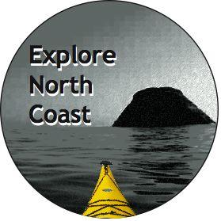
ORDER FORM
Sea Kayaking the Redwood Coast

Explore North Coast
P.O. Box 4712
Arcata, CA. 95518
707-825-9221

Purchased by:
Name:
Address:
City, State, Zip

Ship to (enter “Same” if the information is the same as Purchased by above):
Name:
Address:
City, State, Zip

Order:
Quantity | Unit Price | Line Total
 | $14.95
 | 8% tax for California
 | Shipping**
 | TOTAL

**Shipping cost is $2.50 per single book or $2.00 per book when multiple copies are purchased in one order.

Make checks payable to Explore North Coast.
Send this order form with payment to the address above.

Thank you for purchasing our book. Happy and safe paddling!

